**Gas Leakage Monitoring and**

**Alerting System**

***JERIN E, MAHALAKSHMI B, ASHWANTH KUMAR K S, JANANTH R***

*( Department of Electronics and Communication Engineering )*

**Introduction :-**

Now a days the home safety detection system plays the important role for the security of people. Since all the people from the home goes to work on daily bases, it makes impossible to check on the appliances available at home specially LPG gas cylinder, wired circuits, Etc. Since last three years there is a tremendous hike in the demands of liquefied petroleum gas (LPG) and natural gas. To meet this access amount of demand for energy and replace oil or coal due to their environmental disadvantage, LPG and natural gas are preferred. These gases are mostly used on large scale in industry, heating, home appliances and motor fuel. So as to track this leakage gas, the system includes MQ6 gas sensor. This sensor senses the amount of leak gas present in the surrounding atmosphere. Through this, explosion or getting affected by the leakage of gas could be avoided.

**LITRATURE SURVEY**

A system was designed to identify and measure methane gas in the zones of flammable gas stockpile sites. The device measures the air and water quality, including every parameter that can have deviation as the result of gas leakage in the water or air. The sensors measure the amount of CH4 and CO2 gas in the air while the temperature, pH, and electrical conductivity of the water are monitored. The device is controlled by an

Arduino UNO microcontroller that transmits measured data to the database on Raspberry Pi 3.

Different advancements in pipeline leakage detection were put forward. This includes acoustic emission, optic fiber sensor, ground penetrating radar, Vapour sampling and infrared thermography. A system with sensors are connected to arduino for data collection and it uses LabVIEW as the GUI (graphical user interface).

A detailed sensor list for flammable toxic and combustible gases and their possible advantages and disadvantages has been compared. One such example is the SB-95 sensor, which detects sequentially the variation on the methane and carbon monoxide gas concentration and modifies its resistance accordingly. The variation in the filament resistivity is transmitted as a voltage variation on the load resistor. At the same time, metal oxide sensors have a long response time and even longer recovery time. These sensors need to extract the gas by making a hole into the pipe for the gas concentration measurement. Making holes can cause danger such as leakage or explosion of the toxic gas.

On the other hand, ultrasonic sensors are free from the above disadvantages for the measurement of gas concentration with fast response time and the device is compact and inexpensive too.

A detailed study of health issues related to gases like hydrogen sulphide, Carbon monoxide and methane has been done. Activation of optical alarms and buzzers when the sensed values of SB-95 sensor goes above the threshold along with the working of the sensor is explained in detail. Table gives a reference about the sources and flammable limits of Hydrocarbons and Hydrogen Sulphide gas.Even though the sources of leaks of both the types of gases are common, the lower range of flammability of hydrocarbons are less than hydrogen sulphide which makes their leaks vulnerable to explosions. At the same time the toxicity of hydrogen sulphide is seen as 50ppm which can really cause lots of health issues in humans and continuous exposure may even lead to death.

**PROPOSED SOLUTION:-**

**IDEATION PROPOSED SOLUTION:-**

Internet of Things aim towards making life simpler by automating every small task around us. As much is IoT helping in automating tasks, the benefits of IoT can also be extended for enhancing the existing safety standards. Safety has always been an important criterion while designing home, buildings, industries as well as cities. The increased concentration of certain gases in the atmosphere can prove to be extremely dangerous. These gases might be flammable at certain temperature and humidity conditions, toxic after exceeding the specified concentrations limits or even a contributing factor in the air pollution of an area leading to problems such as smog and reduced visibility which can in turn cause severe accidents and also have adverse effect on the health of people. Most of the societies have fire safety mechanism. But it can use after the fire exists. In order to have a control over such conditions we proposed system that uses sensors which is capable of detecting the gases such as LPG, CO2, CO and CH4. This system will not only able to detect the leakage of gas but also alerting through audible alarms. Presence of excess amounts of harmful gases in environment then this system can notify the user. System can notify to society admin about the condition before mishap takes place through a message.

**Proposed method :-**

Arduino UNO (Atmega-328) is the main unit of the system which performs the following tasks. A signal conditioning of the Arduino UNO is done by output signal of the sensor, provided input to Arduino. The detection results displayed on LCD. Indicates the people of danger in work place, factory, home. Buzzer activity with beep(siren) sound is made. Also send alert SMS to the in charge of the plant whose number is saved in SIM card by using GSM modem. The SMS received depends upon the leak of gas in the detection area of the sensor.

**Empathy Map Canvas**



**REQUIREMENT ANALYSIS**

**Functional requirement;**

|  |  |  |
| --- | --- | --- |
| **Business Requirements** | **User Requirements** | **Product Requirements** |
| The said system can be deployed in homes, hotels, factory units, LPG cylinder storage areas, and so on. The main advantage of this IoT and Arduino-based application is that it can determine the leakage and send the data over to a site. It can be monitored, and preventive measures can be taken to avoid any disaster. | The gas leakage detection system can be optimized for detecting toxic gasses along with upgrading them with smoke and fire detectors to identify the presence of smoke and fire. Ensuring worker safety is important but making using of the right technology is even more vital. | Detecting gasses is necessary regardless of your business role or individual purpose. Certain technologies at play make such IoT devices what they are, and if you want to indulge in IoT application development, you must know what they are and what  purpose they can fulfill. |

**PROJECT DESIGN;**

**Data Flow Diagrams;**

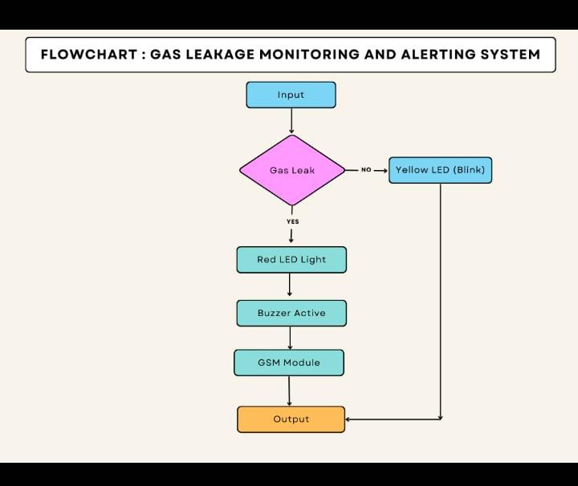

**Solution & Technical Architecture**



**PROJECT PLANNING & SCHEDULING**

**Sprint Planning & Estimation**



**CODING & SOLUTIONING**

//Code for Blinking LED//

import RPi.GPIO as GPIO

import time

LED = 40

GPIO.setwarnings(False)

GPIO.setmode(GPIO.BOARD)

GPIO.setup(LED, GPIO.OUT)

while True:

GPIO.output(LED,GPIO.HIGH)

time.sleep(1)

GPIO.output(LED,GPIO.LOW)

time.sleep(1)

//Code for Traffic Light System//

from gpiozero import Button, TrafficLights, Buzzer

from time import sleep

buzzer = Buzzer(15)

button = Button(21)

lights = TrafficLights(25, 8, 7)

while True:

button.wait_for_press()

buzzer.on()

light.green.on()

sleep(1)

lights.amber.on()

sleep(1)

lights.red.on()

sleep(1)

lights.off()

buzzer.off()

**Solution Statement :-**

The system can be taken as a small attempt in connecting the existing primary gas detection methods to a mobile platform integrated with IoT platforms. The gases are sensed in an area of 1m radius of the rover and the sensor output datas are continuously transferred to the local server. The accuracy of sensors are not upto the mark thus stray gases are also detected which creates an amount of error in the outputs of the sensors, especially in case of methane. Further the availability and storage of toxic gases like hydrogen sulphide also creates problems for testing the assembled hardware. As the system operates outside the pipeline, the complication of system maintenance and material selection of the system in case of corrosive gases is reduced. Thus the system at this stage can only be used as a primary indicator of leakage inside a plant.

**Conclusion :-**

After this project performance, can conclude that detection of the LPG gas leakage is incredible in the project system. Applicable usefully in the industrial and domestic purpose. In danger situations we are able to save the life by using this system. An alert is indicated by the GSM module. A sensor node senses gas like CO2, oxygen, propane. The estimated range of transmission and consumption of power is obtained. The simple procedures and Arduino UNO Micro controller area used to build the sensor.

**APPENDIX;**

**Source Code;**

#include <LiquidCrystal.h>

LiquidCrystal lcd(5,6,8,9,10,11);

int redled = 2;

int greenled = 3;

int buzzer = 4;

int sensor = A0;

int sensorThresh = 400;

void setup()

{

pinMode(redled, OUTPUT);

pinMode(greenled,OUTPUT);

pinMode(buzzer,OUTPUT);

pinMode(sensor,INPUT);

Serial.begin(9600);

lcd.begin(16,2);

}

void loop()

{

int analogValue = analogRead(sensor);

Serial.print(analogValue);

if(analogValue>sensorThresh)

{

digitalWrite(redled,HIGH);

digitalWrite(greenled,LOW);

tone(buzzer,1000,10000);

lcd.clear();

lcd.setCursor(0,1);

lcd.print("ALERT");

delay(1000);

lcd.clear();

lcd.setCursor(0,1);

lcd.print("EVACUATE");

delay(1000);

}

else

{

digitalWrite(greenled,HIGH);

digitalWrite(redled,LOW);

noTone(buzzer);

lcd.clear();

lcd.setCursor(0,0);

lcd.print("SAFE");

delay(1000);

lcd.clear();

lcd.setCursor(0,1);

lcd.print("ALL CLEAR");

delay(1000);

}

}

**PYTHON CODE**

//Code for Blinking LED//

import RPi.GPIO as GPIO

import time

LED = 40

GPIO.setwarnings(False)

GPIO.setmode(GPIO.BOARD)

GPIO.setup(LED, GPIO.OUT)

while True:

GPIO.output(LED,GPIO.HIGH)

time.sleep(1)

GPIO.output(LED,GPIO.LOW)

time.sleep(1)

//Code for Traffic Light System//

from gpiozero import Button, TrafficLights, Buzzer

from time import sleep

buzzer = Buzzer(15)

button = Button(21)

lights = TrafficLights(25, 8, 7)

while True:

button.wait_for_press()

buzzer.on()

light.green.on()

sleep(1)

lights.amber.on()

sleep(1)

lights.red.on()

sleep(1)

lights.off()

buzzer.off()

**GitHub;**

**https://github.com/IBM-EPBL/IBM-Project-43793-1660719663**